**Experiment No:5**

**Demonstrate the working principle of Refrigeration Cycle**

**Introduction:**

Refrigeration cycle a reverse thermodynamic **cycle** whereby heat is transferred from a body with a lower temperature to a body with a higher temperature owing to the expenditure of work. **Refrigeration cycles** are used in refrigerating machines and in gas refrigerators.

**Diagram:**

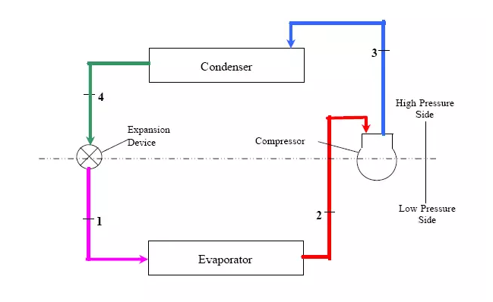

Fig no 5.1: diagram of refrigeration cycle

**Principles of Refrigeration cycle:**

* Liquids absorb heat when changed from liquid to gas
* Gases give off heat when changed from gas to liquid.

**Processes:**

There are four processes taking place in the whole cycle:

* **Compressor:**

The compressor is widely considered the engine of the refrigeration cycle. It consumes the most power out of the HVAC system’s components and forces the refrigerant through the system. In the process of being compressed the cool, gaseous refrigerant is turned to a very hot and high-pressure vapor.

* **Condenser:**

The **condenser’s**job is to cool the refrigerant so that it turns a gas into a liquid, or condenses. This happens when warm outdoor air is blown across the condenser coil that is filled with hot, gaseous refrigerant. This allows heat to transfer from the refrigerant to the cooler outdoor air, where the excess heat is rejected to the atmosphere. The condenser coils wind through the condenser to maximize the surface area of the piping, and effectively, the heat transfer to the air. The refrigerant turns from a vapor into a hot liquid due to the high pressure and reduction in temperature.

* **Expansion:**

The refrigerant is now approaching the **expansion device** as a hot, high-pressure liquid. The expansion device is responsible for quickly driving the pressure of the refrigerant down so it can boil (evaporate) more easily in the evaporator — and that’s it! The expansion device has one sole purpose: to reduce refrigerant pressure. Because the pressure drops so rapidly at the expansion device, the refrigerant turns into a combination of a cold liquid and vapor.

* **Evaporator:**

Now that the refrigerant is a cold mix of liquid and gas (vapor), it begins to move through the **evaporator**. The evaporator is responsible for cooling the air going to the space by boiling (evaporating) the refrigerant flowing through it. This happens when warm air is blown across the evaporator as cold refrigerant moves through the evaporator coil. Heat transfers from the air to the refrigerant, which cools the air directly before it is vented to the space. Like the condenser coil, the evaporator coil also winds through the evaporator to maximize heat transfer from the refrigerant to the air. The low-pressure liquid refrigerant is easily boiled by the warm air blown across the evaporator and heads back to the compressor as a cool gas/vapor.

**PV diagram of refrigeration cycle:**

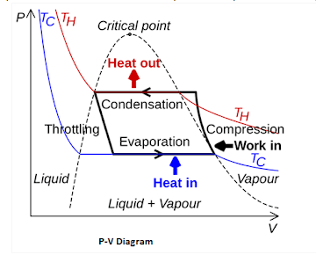

**TS diagram:**

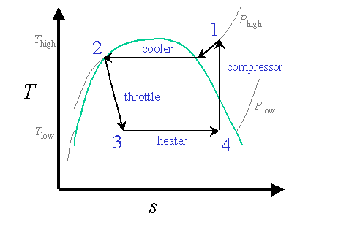

**TV diagram:**

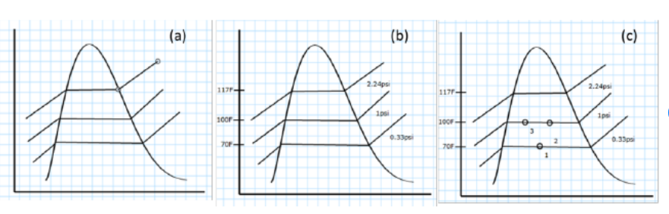

Three levels in a refrigeration cycle T-v diagram.

**(a).** A vapor dome with three pressures.

**(b).** Labels of phase-change temperature and pressure values were added.

**(c).** State information was anchored on the pressure line.

**Explanation:**

For an air conditioning system to operate with economy, the refrigerant must be used repeatedly. For this reason, all air conditioners use the same cycle of compression, condensation, expansion, and evaporation in a closed circuit. The same refrigerant is used to move the heat from one area, to cool this area, and to expel this heat in another area.

* The refrigerant comes into the compressor as a low-pressure gas, it is compressed and then moves out of the compressor as a high-pressure gas.
* The gas then flows to the condenser. Here the gas condenses to a liquid, and gives off its heat to the outside air.
* The liquid then moves to the expansion valve under high pressure. This valve restricts the flow of the fluid, and lowers its pressure as it leaves the expansion valve.
* The low-pressure liquid then moves to the evaporator, where heat from the inside air is absorbed and changes it from a liquid to a gas.
* As a hot low-pressure gas, the refrigerant moves to the compressor where the entire cycle is repeated.

Note that the four-part cycle is divided at the center into a high side and a low side This refers to the pressures of the refrigerant in each side of the system.

**Applications:**

Probably the most widely used current applications of refrigeration are for air conditioning of private homes and public buildings, and refrigerating foodstuffs in homes, restaurants and large storage warehouses. The use of refrigerators in kitchens for storing fruits and vegetables has allowed adding fresh salads to the modern diet year round, and storing fish and meats safely for long periods. The optimum temperature range for perishable food storage is 3 to 5 °C (37 to 41 °F).